**UNIT-1**

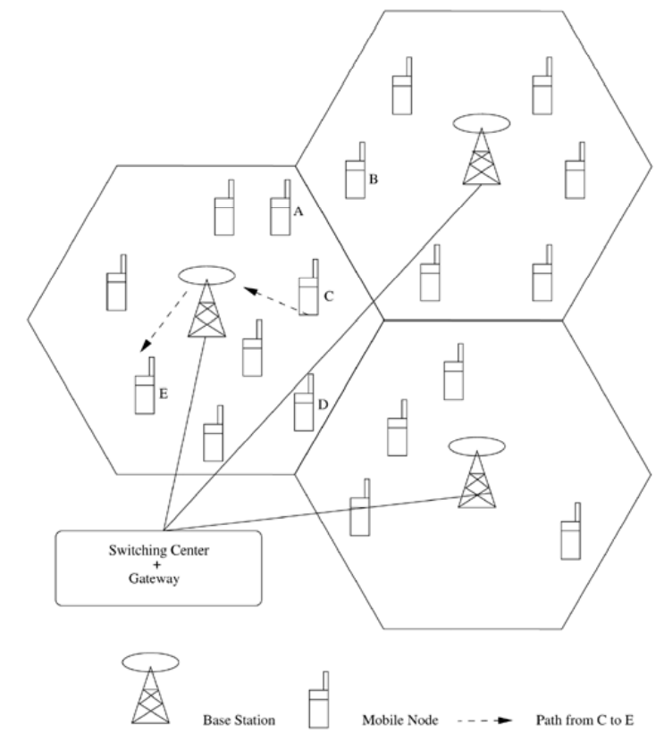

Ad hoc wireless networks are defined as the category of wireless networks that utilize multi-hop radio relaying and are capable of operating without the support of any fixed infrastructure (hence they are also called infrastructureless networks). The absence of any central coordinator or base station makes the routing a complex one compared to cellular networks.

The path setup for a call between two nodes, say, node C to node E, is completed through the intermediate mobile node F, as illustrated in Figure.

Wireless mesh networks and wireless sensor networks are specific examples of ad hoc wireless networks.

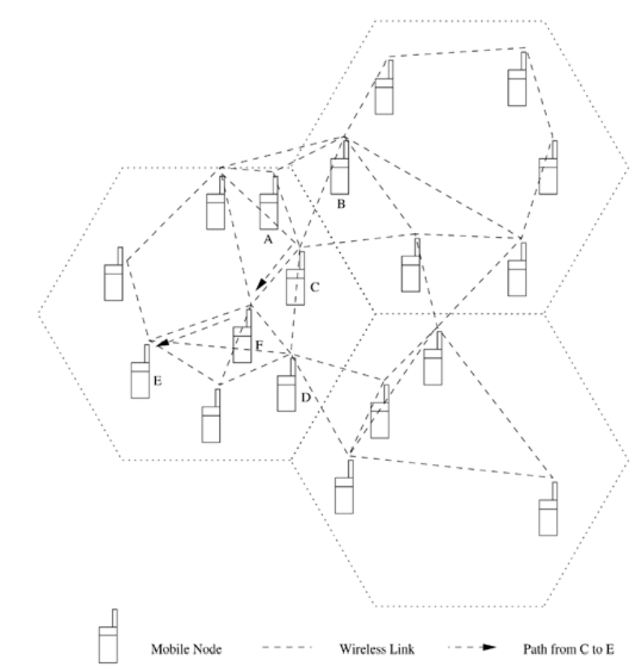

The presence of base stations simplifies routing and resource management in a cellular network as the routing decisions are made in a centralized manner with more information about the destination node.

But in an ad hoc wireless network, the routing and resource management are done in a distributed manner in which all nodes coordinate to enable communication among themselves. This requires each node to be more intelligent so that it can function both as a network host for transmitting and receiving data and as a network router for routing packets from other nodes. Hence the mobile nodes in ad hoc wireless networks are more complex than their counterparts in cellular networks.

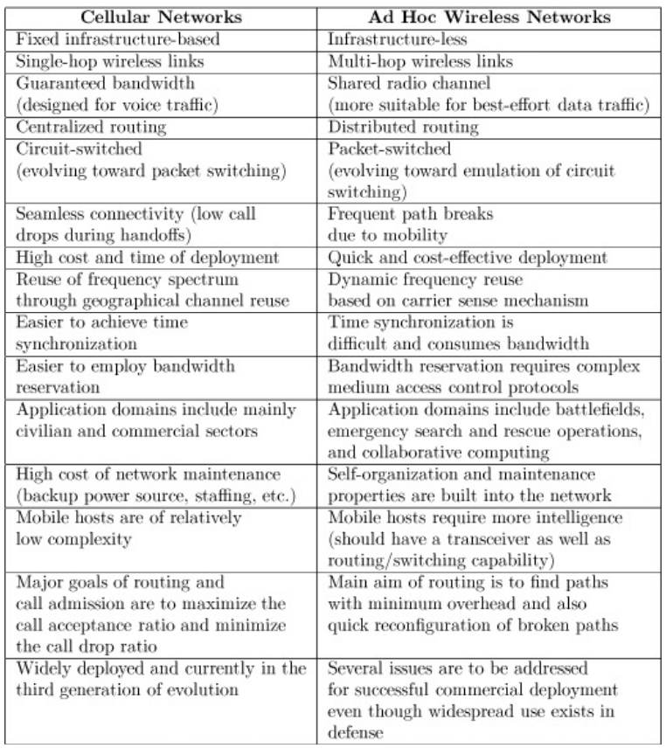

**Applications of Ad Hoc Wireless Networks**

1. **Military Applications**

Ad hoc wireless networks can be very useful in establishing communication among a group of soldiers for tactical operations. Setting up a fixed infrastructure for communication among a group of soldiers in enemy territories or in inhospitable terrains may not be possible. In such environments, ad hoc wireless networks provide the required communication mechanism quickly.

Another application in this area can be the coordination of military objects moving at high speeds such as fleets of airplanes or warships. Such applications require quick and reliable communication. Secure communication is of prime importance as eavesdropping or other security threats can compromise the purpose of communication or the safety of personnel involved in these tactical operations. They also require the support of reliable and secure multimedia multicasting.

For example, the leader of a group of soldiers may want to give an order to all the soldiers or to a set of selected personnel involved in the operation. Hence, the routing protocol in these applications should be able to provide quick, secure, and reliable multicast communication with support for real-time traffic.

As the military applications require very secure communication at any cost. They can have multiple high-power transceivers, each with the ability to hop between different frequencies for security reasons. Such communication systems can be assumed to be equipped with long-life batteries that might not be economically viable for normal usage. They can even use other services such as location tracking [using the global positioning system (GPS)] or other satellite-based services for efficient communication and coordination. Resource constraints such as battery life and transmitting power may not exist in certain types of applications of ad hoc wireless networks. For example, the ad hoc wireless network formed by a fleet of military tanks may not suffer from the power source constraints present in the ad hoc network formed by a set of wearable devices used by the foot soldiers.

1. **Collaborative and Distributed Computing**

Another domain in which the ad hoc wireless networks find applications is collaborative computing. The requirement of a temporary communication infrastructure for quick communication with minimal configuration among a group of people in a conference or gathering necessitates the formation of an ad hoc wireless network.

For example, consider a group of researchers who want to share their research findings or presentation materials during a conference, or a lecturer distributing notes to the class on the fly. In such cases, the formation of an ad hoc wireless network with the necessary support for reliable multicast routing can serve the purpose.

The distributed file sharing applications utilized in such situations do not require the level of security expected in a military environment. But the reliability of data transfer is of high importance.

Devices used for such applications could typically be laptops with add-on wireless interface cards, enhanced personal digital assistants (PDAs), or mobile devices with high processing power.

1. **Emergency Operations**

Ad hoc wireless networks are very useful in emergency operations such as search and rescue, crowd control, and commando operations.

The major factors that favor ad hoc wireless networks for such tasks are self-configuration of the system with minimal overhead, independent of fixed or centralized infrastructure, the nature of the terrain of such applications, the freedom and flexibility of mobility, and the unavailability of conventional communication infrastructure.

1. **Wireless Mesh Networks**

Wireless mesh networks are ad hoc wireless networks that are formed to provide an alternate communication infrastructure for mobile or fixed nodes/users, without the spectrum reuse constraints and the requirements of network planning of cellular networks.

The mesh topology of wireless mesh networks provides many alternate paths for a data transfer session between a source and destination, resulting in quick reconfiguration of the path when the existing path fails due to node failures.

Wireless mesh networks provide the most economical data transfer capability coupled with the freedom of mobility.

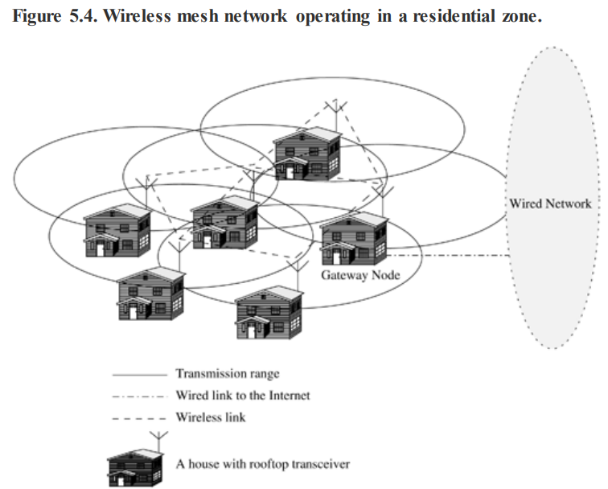

1. **Wireless Sensor Networks**

ISSUES IN AD HOC WIRELESS NETWORKS

1. Medium access scheme
2. Routing
3. Multicasting
4. Transport layer protocol
5. Pricing scheme
6. Quality of service provisioning
7. Self-organization
8. Security
9. Energy management
10. Addressing and service discovery
11. Scalability
12. Deployment considerations